**FACIAL IDENTIFICATION**

***Bighnesh Lenka***

***Admission no: 212121160***



**Department of CSA**

**Centre for Post Graduate Studies**

**Odisha University of Agriculture and Technology Bhubaneswar-2023**

**FACIAL IDENTIFICATION**

*A Project report submitted to the*

*Odisha University of Agriculture and Technology in partial fulfilment of the requirement for the*

*degree of Master of Computer Science and Application By*

*Name: Bighnesh Lenka*

*Adm No: 212121160*



**Department of CSA**

**Centre for Post Graduate Studies**

**Odisha University of Agriculture and Technology**

**Bhubaneswar-2023**



**Odisha University of Agriculture and Technology**

**Centre for Post Graduate Studies**

**Department of Computer Science and Application**

**CERTIFICATE**

This is to certify that the project report entitled “**FACIAL IDENTIFICATION**” submitted in partial fulfilment of the requirements for the award of the degree of Master of Computer Applications to the Odisha University of Agriculture and Technology is a faithful record of bonafide and original research work carried out by **Bighnesh Lenka** under my guidance and supervision. No part of this Project has been submitted for any other degree or diploma. It is further certified that the assistance and help received by him from various sources during the course of investigation has been duly acknowledged.

**Mr. Abhimanyu Dash**

**(Advisor)**



**Odisha University of Agriculture and Technology**

**Centre for Post Graduate Studies**

**Department of Computer Science and Application**

**CERTIFICATE**

This is to certify that the project report entitled “**FACIAL IDENTIFICATION”** submitted by **Bighnesh Lenka** to the Odisha University of Agriculture and Technology, Bhubaneswar in partial fulfilment of the requirements for the degree of Master of Computer Applications has been approved/disapproved by the students’ advisory committee and the external examiner.

**Advisory Committee**

**Chairman:** Dr. Abhimanyu Dash

Head of the Department, **-----------------------------------**

Department of CSA

**Member:** Dr. Abhimanyu Dash

Head of the Department, **-----------------------------------**

Department of CSA

**Member:** Dr. Rasmi Ranjan Patra

Assistant Professor, **-----------------------------------**

Department of CSA

**External Examiner**: **-----------------------------------**

**ACKNOWLEDGEMENT**

I am grateful to **Dr. Abhimanyu Dash,** project guide, OUAT,Bhubaneswar, for assigning me this innovation project and modelling me both technically and morally for achieving greater success in my study life.

It is a great sense of satisfaction that my first real live venture in practical computing is in the form of project work. I extend my humble obligation towards **Dr. Abhimanyu Dash,** HOD, Dept. Of Computer Science and Application, Centre for Post Graduate Studies, OUAT for providing us with an environment to study and our career.

I express my profound gratitude and indebtedness to **Dr. Rasmi Ranjan Patra**, Asst. Professor, for his unending support right from the conceptualization of the idea till the evolution of the software, **Dr. Jyoti Ranjan Mohanty**, Asst. Professor, for his constant support and motivation, **Dr. Sanjibani Sudha Pattnaik**, Asst. Professor, for her useful suggestions given during the course of the project period, **Mrs. Shubhadra Mohanty**, Asst. Professor, CSA for her vital encouragement and support, **Mrs. Debaswapna Mish**ra, Asst. Professor, for the help and inspiration**, Mrs. Tanuja Panda**, Asst. professor, for her understanding and assistance.

Above all, I thank the almighty without whose grace and blessings I would not have been able to complete my work successfully.

**Date: Bighnesh Lenka**

**Place: Adm. No: 212121160**

**ABSTRACT**

Facial identification is a cool project where we teach computers to recognize people's faces. This helps with security, like unlocking your phone or finding bad guys in videos. In this project, we explain how it works and what problems it can have. We use clever math and computer tricks to make it work well.

But sometimes it can make mistakes and might not work for everyone. We also talk about being fair and not treating people differently because of their looks.

We look into the future and talk about what's coming next in facial identification. We want to make sure it's helpful and doesn't hurt anyone. So, we need rules and good ways to use it. This project is about using this cool technology in the right way.

**CONTENTS**

**1. Introduction: 1**

2. Objectives and Goals of The Project: 2

**3. Installation: 4**

3.1 Prerequisites: 4

3.2 Installation of required libraries: 6

**4. Usage of Facial Identification: 8**

4.1 Using Images: 8

4.2 Using Webcam Input for Real-Time Analysis: 9

**5. Project architecture: 11**

5.1 Overview: 11

**6. Data Handling: 14**

6.1 Data Collection: 14

6.2 Data Preprocessing: 14

6.3 Model Analysis: 15

6.4 Data Integration: 16

6.5 Visualization and User Interaction: 16

6.6 Storage and Logging: 16

6.7 Legal and Ethical Considerations: 16

**7. Datasets: 18**

7.1 Overview of the datasets: 18

7.2 Brief description of UTKFace and CK+ datasets: 20

7.3 Preprocessing steps applied to the data: 24

**8.Exploratory Data Analysis (EDA): 28**

8.1 Overview: 28

8.2 Dataset Exploration: 28

8.3 Image Preprocessing: 29

8.4 Data Statistics: 30

8.5 Correlation Analysis: 33

8.6 Key Insights: 33

**9. Model Training: 34**

9.1 Data Collection: 34

9.2 Data Preprocessing: 34

9.3 Model Architecture: 34

9.4 Loss Function: 34

9.5 Optimizer: 34

9.6 Training: 35

9.7 Evaluation: 35

9.8 Fine-tuning: 35

9.9 Plotting the Gender Model: 36

9.10 Plotting the Age Model: 37

9.11 Plotting the Emotion Model: 38

**10. Face Detection: 39**

10.1 Introduction: 39

**11. Results: 42**

11.1 Python Environment Setup: 42

11.2 For Sample Images: 42

11.3 For Real-Time Webcam Input: 45

11.4 Analysis: 47

**12. Performance Metrics: 48**

12.1 Introduction: 48

12.2 Visualization: 50

**13. Challenges and Solutions: 53**

13.1 Data Quality and Diversity: 53

13.2 Model Accuracy and Generalization: 53

13.3 Real-Time Performance: 53

13.4 Interpreting Complex Emotions: 53

13.5 Adapting to Varied Environments: 53

**14. Future Enhancements: 54**

14.1 Multimodal Fusion: 54

14.2 Advanced Models and Architectures: 54

14.3 Real-Time Performance Enhancements: 54

14.4 Contextual Analysis: 55

14.5 Personalization and Adaptability: 55

14.6 Explainable AI and Transparency: 55

14.7 Robustness to Diverse Conditions: 55

14.8 Continuous Learning and Feedback: 56

14.9 Ethical Considerations and Fairness: 56

14.10 User Interaction and Engagement: 56

**15. Conclusion: 57**

15.1 Findings: 57

15.2 Outcomes: 57

15.3 Lessons Learned: 58

**References 59**

# 

# 1. Introduction:

The "Facial Identification" project is a computer vision application that leverages machine learning and deep learning techniques to analyse human faces from images, videos or real-time webcam feeds. The primary goal of this project is to perform three key tasks: emotion detection, age estimation, and gender recognition. By applying state-of-the-art models and leveraging popular libraries such as Keras, TensorFlow, openCV, Pandas, NumPy, and Matplotlib, the project aims to provide accurate and efficient facial analysis capabilities.

The project enables users to extract valuable insights from facial data, making it suitable for various applications, including security systems, personalized user experiences, and social analysis. Whether it's for academic research, commercial applications, or personal use, the "Facial Identification" project offers a versatile tool for understanding and categorizing facial attributes. This documentation will guide users through the installation, configuration, and usage of the project, empowering them to harness the power of facial identification technology.

# 

# 2. Objectives and Goals of The Project:

### Facial Emotion Detection:

* + Objective: To accurately recognize and classify emotions displayed on human faces, including positive (happy), neutral and negative (sad).
  + Goal: Develop a robust emotion detection model that can be used in applications like security systems , personalized user experiences and healthcare.

### Age Estimation:

* + Objective: To estimate the age of individuals based on their facial features.
  + Goal: Create an age estimation model that provides precise age predictions for a wide range of age groups, enabling applications in age-restricted content filtering and targeted marketing.

### Gender Recognition:

* + Objective: To determine the gender of individuals by analyzing facial characteristics.
  + Goal: Build a gender recognition model that can identify gender with high accuracy, supporting applications in customer profiling and security systems.

### Real-Time Webcam Support:

* + Objective: Enable real-time facial identification using a webcam feed.
  + Goal: Implement a user-friendly interface that allows users to interact with the project in real-time, facilitating live analysis and feedback.

### Scalability and Performance:

* + Objective: Ensure the project can handle a variety of image sources and provide efficient results.
  + Goal: Optimize the project's performance for speed and resource efficiency, making it suitable for real-world, high-throughput scenarios.

### Documentation and Education:

* + Objective: Provide comprehensive documentation to guide users on installation, usage, and troubleshooting.
  + Goal: Ensure that users have the necessary resources and information to understand, use, and potentially contribute to the project.

### Versatility and Customization:

* + Objective: Allow users to adapt and customize the project to their specific needs.
  + Goal: Provide flexibility through configurable parameters and support for different facial identification models or datasets.

### Research and Innovation:

* + Objective: Contribute to the field of computer vision and facial analysis by staying up-to-date with the latest research and implementing cutting-edge techniques.
  + Goal: Keep the project on the forefront of technological advancements in facial identification.

The "Facial Identification" project seeks to address these objectives and goals to provide a valuable tool for a wide range of applications, from market research and security to personal analysis and academic research.

# 3. Installation:

## 3.1 Prerequisites:

Prerequisites for a facial identification project include the following:

### Python Environment:

* + Python version 3.11.0 installed on the system.

### Libraries and Frameworks:

* + Installed libraries and frameworks, including but not limited to:
    - OpenCV: For Haar Cascade face detection.
    - Keras: A high-level neural networks API.
    - TensorFlow: An open-source machine learning framework.
    - NumPy: For numerical operations on data.
    - Pandas: For data manipulation and analysis.
    - Matplotlib: For data visualization.
    - Seaborn: For data visualization which works on top of matplotlib.
    - Pillow: For adding image processing capabilities.
    - Other libraries for specific tasks.

### GPU Support:

* + Having a compatible NVIDIA GPU can significantly accelerate training times. But the Google Colab environment was used here.

### Data Collection:

* + Gather a dataset of images containing faces for training and testing your models. The quality and diversity of your dataset can impact the performance of your facial identification system.

### Model Pretrained Weights:

* + For deep learning models, you may want to use pre-trained model weights for transfer learning. Ensure that you have access to these weights if needed.

### Jupyter Notebook:

* + Jupyter notebooks are helpful for interactive development and experimentation. Install Jupyter if you prefer this environment.

### Development Environment:

* + An integrated development environment (IDE) or code editor such as Visual Studio Code, Google Colab, or Jupyter Notebook.

### Webcam (For Real-Time Analysis):

* + To implement real-time facial identification access to a webcam or external camera was provided.

### Internet Connection:

* + internet connection was necessary for downloading additional resources, model weights, or updates for libraries and packages.

### Operating System Compatibility:

* + Windows Operating System environment was used in development of the system.

### Legal and Ethical Considerations:

* + Legal and ethical considerations, especially regarding data privacy and consent when working with facial data. Complied with relevant data protection regulations.

### Documentation:

* + Relevant documentation is created about the experimentation process.

## 3.2 Installation of required libraries:

To install the required libraries for a facial identification project, the Python package manager pip for package management. Here are the commands that were used to install the necessary libraries:

### OpenCV (for Haar Cascade face detection and image processing):

pip install opencv-python

### Keras (for deep learning):

pip install keras

### TensorFlow (for deep learning, backend for Keras):

pip install tensorflow

### NumPy (for numerical operations on data):

pip install numpy

### Pandas (for data manipulation and analysis):

pip install pandas

### Matplotlib (for data visualization):

pip install matplotlib

### 7.Jupyter Notebook:

pip install jupyter

After running these commands, the necessary libraries were installed on the system so that we can start working on the facial identification project. The Python environment was correctly set up, and any dependencies were met, as mentioned in the prerequisites section.

# 

# 

# 

# 

# 

# 4. Usage of Facial Identification:

To use the Facial Identification system, which includes emotion detection, age estimation, and gender recognition, the user needs to follow these instructions for both image and webcam input modes:

## 4.1 Using Images:

### Preparation:

User needs make sure that all the prerequisites and required libraries are installed on our system, as mentioned in the previous instructions.

### Data Preparation:

User needs to Collect the images that are needed to be analyzed for facial identification. Ensure that the images contain one or more faces to perform the desired tasks.

### Loading the models:

User needs to navigate to the directory where the facial identification project is located. Open the “Final.ipynb” file and run the cells one after another.

This should load the required models for emotion detection, age estimation, and gender recognition.

### Specify Image Path:

In the script the user needs to give a path to the image they want to analyze.

### Processing and Analysis:

The script will perform facial identification tasks on the image, including emotion detection, age estimation, and gender recognition.

### Results:

The system will provide results, which may include detected emotions (e.g., happy, sad, angry), estimated age, and recognized gender.

## 4.2 Using Webcam Input for Real-Time Analysis:

### Preparation:

The user needs to make sure that they have all the prerequisites and required libraries installed on our system, as mentioned in the previous instructions.

### Loading the models:

User needs to navigate to the directory where the facial identification project is located. Open the “Final.ipynb” file and run the cells one after another.

This should load the required models for emotion detection, age estimation, and gender recognition.

### Execute the Webcam Script:

On the Jupyter Notebook/Google Colab environment run the script section for real-time facial identification using a webcam.

### Webcam Initialization:

The script will access the system's webcam and display the camera feed.

### Real-Time Analysis:

As the webcam feed is displayed, the system will continuously perform facial identification tasks on the faces it detects in the real-time video.

### Results:

The results, including detected emotions, estimated age, and recognized gender, will be displayed in real-time or recorded for later review.

# 5. Project architecture:

## 5.1 Overview:

The structure of a facial identification system involves various components or modules that work together to perform tasks like emotion detection, age estimation, and gender recognition. Below is an overview of how different components/modules interact in a facial identification system:

### Data Input:

* + The system can receive data in the form of images or real-time video feeds from a webcam. This data serves as the input for the facial identification process.

### Preprocessing:

* + Before analysis, the input data goes through preprocessing to prepare it for analysis. This may include tasks such as resizing, normalization, and enhancing image quality.

### Face Detection (Haar Cascade):

* + The Haar Cascade classifier is used to detect faces within the input data. It identifies the location of faces in images or frames from the webcam feed.

### Emotion Detection Model:

* + Once faces are detected, the system passes the face regions to an emotion detection model. This model analyzes facial expressions and recognizes emotions, such as happiness, sadness, anger, and more.

### Age Estimation Model:

* + Another module takes the detected faces and estimates the age of the individuals. This module can provide an approximate age range based on facial features.

### Gender Recognition Model:

* + Similarly, the system employs a gender recognition model to determine the gender of the individuals in the images. It classifies the gender as male or female.

### Integration of Results:

* + The results from the emotion detection, age estimation, and gender recognition modules are integrated to provide a comprehensive analysis of each detected face.
  + This information can be combined and presented in a user-friendly format.

### Visualization:

* + The system includes visualization components to display the results, such as graphical representations, charts, or annotations on the input images or video frames.

### Real-Time Feedback (Webcam Mode):

* + In the case of real-time webcam analysis, the system continuously provides feedback as it detects and analyzes faces. This feedback is displayed in real-time, allowing users to interact with the system.

### User Interaction (Webcam Mode):

* + Users can start and stop the analysis, save results, or perform other interactions with the system, depending on the implementation.

### Storage/Logging (Optional):

* + The system can log the results, allowing users to review the analysis later or store data for further analysis.

The modules within the system work cohesively to provide a complete analysis of the input data, offering insights into the emotions, age, and gender of individuals. The results can be used for various applications, including sentiment analysis, age-related content filtering, demographic profiling, and more. The system's structure is designed to offer versatility and adaptability for different use cases.

# 6. Data Handling:

The management and processing of data in a facial identification project involve several steps, including data collection, preprocessing, and analysis. Here's an explanation of how the project typically manages and processes data, along with common preprocessing steps:

## 6.1 Data Collection:

### Data Sources:

Data can be collected from various sources, such as image datasets, webcam feeds, or video recordings. These sources provide the raw data for analysis.

### Labelling:

If using supervised learning, data may need to be labelled. For example, faces in images can be labelled with emotions, age, and gender for training the models.

## 6.2 Data Preprocessing:

### Image Loading:

In the case of image analysis, the project loads image data from files or other sources.

### Gray Scaling:

Images are gray scaled to reduce dimensionality and to save computational resources at cost of accuracy.

### Resizing:

Images are resized to a consistent resolution to ensure that they are compatible with the models and to save computational resources.

### Face Detection:

Haar Cascade or similar face detection methods identify the location of faces within images.

### Facial Landmarks Detection:

Facial landmarks detection models can be used to locate key points on the face, which can provide additional information for analysis.

## 6.3 Model Analysis:

### Emotion Detection:

Detected face regions are passed to the emotion detection model, which recognizes facial expressions and assigns emotional labels (e.g., happy, sad, neutral).

### Age Estimation:

Another module estimates the age group of the individuals based on the detected faces, providing an approximate age range.

### Gender Recognition:

A gender recognition model classifies the gender of individuals as male or female based on facial features.

## 6.4 Data Integration:

### Combining Results:

The results from the emotion detection, age estimation, and gender recognition modules are integrated to provide a comprehensive analysis for each detected face.

## 6.5 Visualization and User Interaction:

### Visualization:

The system includes visualization components to display the results, such as graphical representations or annotations on the input images.

### Real-Time Feedback (Webcam Mode):

In the case of real-time webcam analysis, the system continuously provides feedback as it detects and analyzes faces. This feedback is displayed in real-time, allowing users to interact with the system.

## 6.6 Storage and Logging:

### Storage/Logging:

The system can log the results for future reference or further analysis. Data can be stored in a database or log files.

## 6.7 Legal and Ethical Considerations:

### Data Privacy and Consent:

Compliance with legal and ethical considerations, such as data privacy and consent, should be integrated into the data management and processing steps, especially in real-time scenarios using webcam input.

The preprocessing steps, data management, and analysis are essential for ensuring that the data is in a suitable format for the models and for generating meaningful insights about the emotions, age, and gender of individuals in the images or video feeds. The specific implementation may vary based on the project's design and requirements.

# 

# 

# 

# 

# 7. Datasets:

## 7.1 Overview of the datasets:

The datasets used for training the models in a facial identification project are crucial for the performance and accuracy of the system. These datasets should be diverse, well-labeled, and representative of the task at hand (emotion detection, age estimation, gender recognition).

Here is an overview of the types of datasets commonly used:

### Emotion Detection Dataset:

* + An emotion detection dataset contains images of individuals displaying various emotions, such as happiness, sadness, anger, fear, disgust, and surprise.
  + The dataset should include a wide range of emotions, ethnicities, ages, and gender representations to ensure the model's generalization.
  + "CK+" (Cohn-Kanade) dataset is used for emotion detection training.

### Age Estimation Dataset:

* + Age estimation datasets consist of images labeled with the actual ages of individuals.
  + The dataset should cover a broad age range, including infants, children, adolescents, adults, and the elderly.
  + "UTKFace" is a popular dataset and it is used for age estimation, which includes a diverse set of faces along with age labels.

### Gender Recognition Dataset:

* + Gender recognition datasets include images labeled with the gender of the individuals, typically as "male" or "female."
  + Similar to other datasets, gender recognition datasets should be diverse and representative of different ethnicities and age groups.
  + "UTKFace" is a popular dataset and it is used for gender recognition training, which includes a diverse set of faces along with gender labels.

### Data Augmentation:

* + To increase the diversity of the training data, data augmentation techniques can be applied. These techniques involve creating new images by applying transformations like rotation, scaling, and flipping to the original dataset.

### Data Labeling and Annotation:

* + Datasets should be labeled and annotated with the target attributes, such as emotions, age, and gender. Annotation can be done manually or using automated tools.

### Data Splitting:

* + Datasets are split into training and testing sets. The training set is used for model training and the testing set is used to evaluate model performance.

### Ethical Considerations:

* + When using facial data, datasets have been collected and used in an ethical manner, with appropriate consent and data privacy measures in place.

### Data Preprocessing:

* + In data preprocessing resizing images to a consistent resolution, normalization of pixel values, and aligning facial landmarks if required.

### Data Balance:

* + A balanced dataset was Ensured, as imbalanced datasets can lead to biased model predictions.
  + For example, there should be a similar number of images for each emotion category in an emotion detection dataset.

## 7.2 Brief description of UTKFace and CK+ datasets:

The "UTKFace" and "CK+" datasets are two commonly used datasets in the field of facial analysis and recognition. Here's a brief description of each dataset:

### UTKFace Dataset:

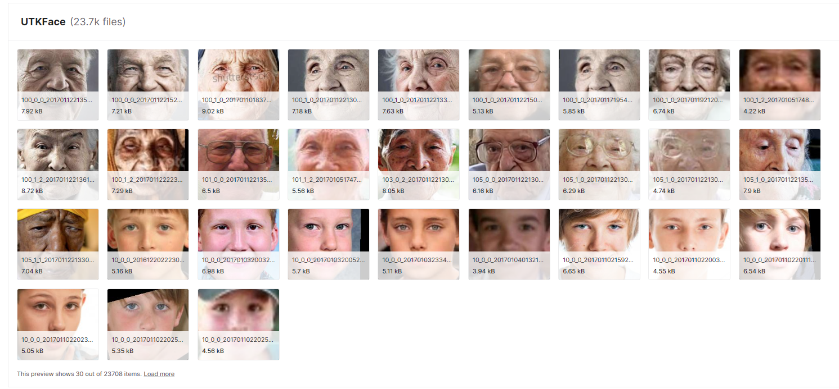

**Full Name:** UTKFace Age, Gender, and Ethnicity Dataset

**Purpose:** The UTKFace dataset is designed for age estimation, gender recognition, and ethnicity classification.

**Contents:** It contains a large collection of facial images, each labeled with the individual's age, gender, and ethnicity.

**Diversity:** UTKFace is known for its diversity, featuring faces from various ethnic backgrounds, ages, and genders.

**Age Range:** The age range covered in the dataset is wide, from infants to elderly individuals.

**Use Cases:** Researchers and developers use UTKFace for training and testing models related to age estimation, gender recognition, and ethnicity classification. It is particularly useful for multi-task models that address multiple facial attributes simultaneously.

**Challenges:** While UTKFace is valuable, it may pose challenges in maintaining balanced class distributions, especially in the ethnicity category, which can have imbalances across different groups.

**Ethical Considerations:** When working with the UTKFace dataset, ethical considerations are crucial, as the dataset includes sensitive attributes such as age, gender, and ethnicity.

### CK+ Dataset:

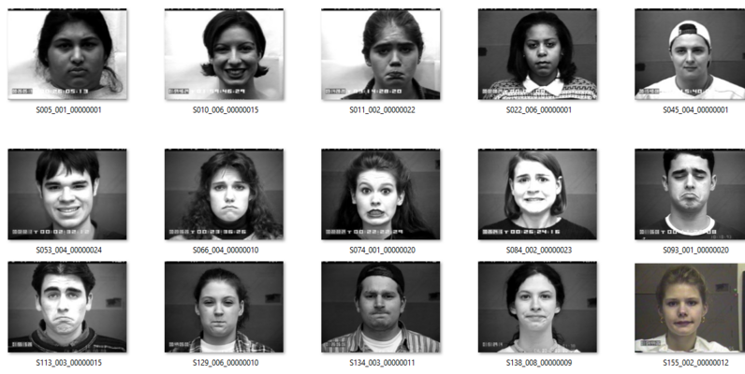

**Full Name:** Cohn-Kanade (CK+) Facial Expression Database

**Purpose:** The CK+ dataset is primarily used for emotion detection and facial expression analysis.

**Contents:** It contains a collection of facial image sequences of individuals displaying a range of emotions, including happiness, sadness, anger, fear, disgust, and surprise. The dataset includes both posed and spontaneous expressions.

**Annotations:** Each image sequence is annotated with the corresponding emotion labels, allowing for supervised training of emotion recognition models.

**Facial Landmarks:** CK+ includes facial landmark annotations, which can be used for more detailed analysis, such as tracking changes in facial expressions over time.

**Use Cases:** CK+ is widely used in research and development related to emotion detection, facial expression analysis, and computer vision applications that require the recognition of emotional states.

**Challenges:** One challenge associated with CK+ is that it predominantly contains posed expressions, which may not fully capture the complexity of spontaneous emotional reactions in real-world scenarios.

**Ethical Considerations:** The CK+ dataset includes images and videos of individuals expressing emotions, which requires responsible handling of the data in accordance with ethical and privacy standards.

Both the UTKFace and CK+ datasets have contributed significantly to the advancement of facial analysis and recognition technologies. Researchers and developers use these datasets to train and evaluate models that can recognize age, gender, ethnicity, and emotions in facial images and video sequences. Ethical considerations, data privacy, and consent are essential when working with these datasets, especially given the sensitive nature of the attributes they capture.

## 7.3 Preprocessing steps applied to the data:

Preprocessing steps are essential in preparing data for training and testing facial identification models. While the specific preprocessing steps can vary depending on the project and dataset, here are some common preprocessing steps applied to facial data:

### Grayscale Conversion:

Convert color images to grayscale if color information is not relevant for the task. Grayscale images require fewer computational resources and may simplify the training process.

**Before Gray Scaling:**



**After Gray Scaling:**



### Image Resizing:

Resize all images to a consistent resolution. This ensures that all images have the same dimensions, making them compatible with the model.

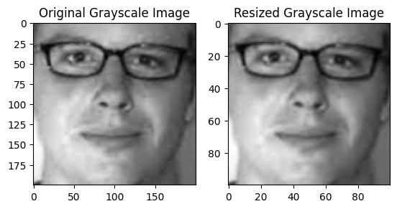

### Facial Region Extraction:

If the dataset includes images with multiple faces or significant background, extract and focus on the facial region of interest. This helps eliminate distractions and irrelevant information.

### Data Augmentation:

Apply data augmentation techniques to increase the diversity of the dataset. Common augmentations include rotation, scaling, flipping, and adding noise to images.

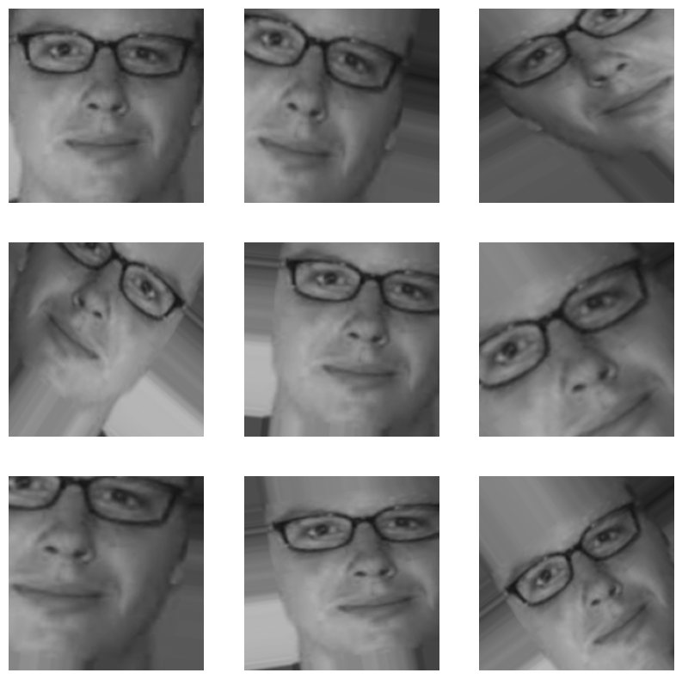

### Histogram Equalization:

Apply histogram equalization to improve the contrast and visibility of facial features. This can be particularly useful in low-contrast images.

### Facial Landmarks Detection:

Detect and annotate facial landmarks (e.g., eyes, nose, mouth) on the images. Landmark detection can provide additional information for tasks like age estimation and emotion recognition.

### Data Balancing:

Ensure that the dataset is balanced with roughly equal representation of different classes or attributes. Imbalanced datasets can lead to biased model predictions.

### Standardization (Z-score):

Standardize image pixel values to have a mean of 0 and a standard deviation of 1. This can assist models in converging faster during training.

### Data Splitting:

Split the dataset into training and testing sets for model training, hyperparameter tuning, and evaluation.

### Handling Missing Data:

The missing or incomplete information in the dataset, consider imputation methods or removal of samples with missing data.

### Ethical Considerations:

Ensuring that the data is handled in compliance with ethical and privacy standards. Remove or anonymize any personally identifiable information and adhere to relevant data protection regulations.

# 8.Exploratory Data Analysis (EDA):

## 8.1 Overview:

The Exploratory Data Analysis (EDA) phase was crucial in understanding the structure and characteristics of the datasets used for training the Facial Identification project. The primary datasets employed were the CK+ Dataset for emotion prediction and the UTK Face Dataset for age and gender prediction.

## 8.2 Dataset Exploration:

### CK+ Dataset (Emotion Prediction):

* Explored the CK+ Dataset containing facial expression images categorized into distinct emotion labels (anger, contempt, disgust, fear, happy, sadness, surprise).
* Visualized sample images to grasp the diversity of facial expressions.
* Plotted a bar graph to represent the distribution of samples across different emotion categories.

### UTK Face Dataset (Age and Gender Prediction):

* Investigated the UTK Face Dataset, which includes facial images labeled with age, gender, and race information.
* Conducted a histogram analysis to understand the distribution of age values.
* Created a chart to showcase the gender distribution in the dataset as well as the age distribution.

## 8.3 Image Preprocessing:

* Converted all images to grayscale to ensure uniformity.
* Resized images to a consistent dimension suitable for model compatibility.



## 8.4 Data Statistics:

* Calculated and visualized basic statistics such as mean, standard deviation, and range of age values in the UTK Face dataset.

Explored the distribution of emotion labels in the CK+ dataset.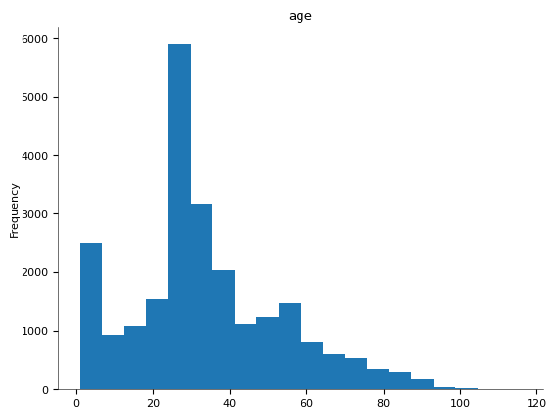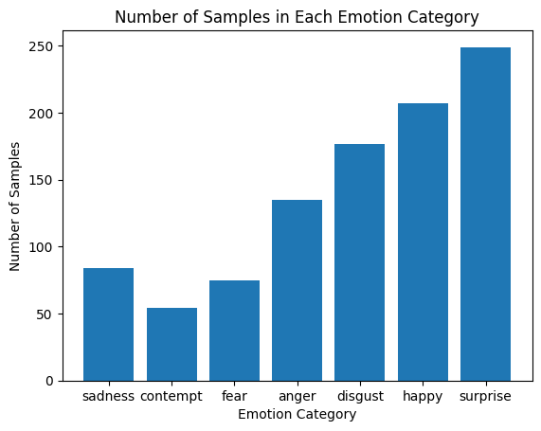

Explored the distribution of age in the UTKFace.

Explored the distribution of gender in the UTKFace.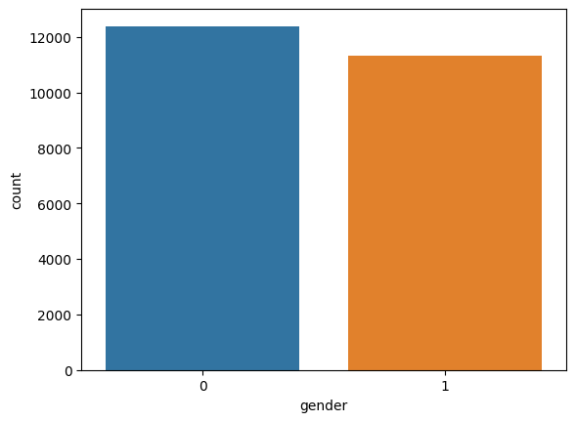

## 8.5 Correlation Analysis:

Investigated potential correlations between age, gender, and specific emotions.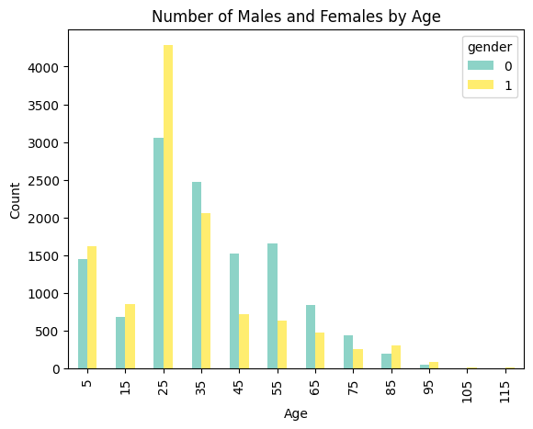

## 8.6 Key Insights:

* Gained a comprehensive understanding of the balance and variety of emotion samples in the CK+ dataset.
* Obtained insights into the age distribution and gender balance in the UTK Face dataset.
* Identified potential correlations between age, gender, and specific emotions through correlation analysis.

# 9. Model Training:

Creating age, gender, and emotion prediction models involves training neural networks on labeled datasets. The process generally follows these steps using TensorFlow and Keras:

## 9.1 Data Collection:

A large dataset of images with labeled age, gender, and emotion information. Diverse and representative datasets are crucial for model generalization.

## 9.2 Data Preprocessing:

Resized images to a consistent size.

Normalized pixel values to a specific range (e.g., 0 to 1).

Augment data if needed (e.g., rotate, flip, or adjust brightness) to increase model robustness.

## 9.3 Model Architecture:

A Convolutional Neural Network (CNN) is commonly used for image-related tasks.

separated the branches in the network for age, gender, and emotion prediction for creating a multi-task model.

## 9.4 Loss Function:

Defined appropriate loss functions for each task (age, gender, and emotion).

## 9.5 Optimizer:

An optimizer (e.g: Adam, SGD) was used for each model to minimize the loss function during training.

## 9.6 Training:

The dataset was split into training and test sets.

Trained the model using the training set and validated it on the validation set.

Adjusted hyperparameters based on validation performance.

Monitored for overfitting and apply regularization techniques to improve accuracy.

## 9.7 Evaluation:

Assess the model's performance on the test set using metrics like accuracy, mean absolute error (MAE), or F1 score, depending on the model.

## 9.8 Fine-tuning:

fine-tuned hyperparameters, adjust the model architecture, or gather additional data.

Here's a simplified example code snippet using TensorFlow and Keras for a gender prediction model:

## 9.9 Plotting the Gender Model:

## 

## 

## 

## 

## 

## 

## 

## 

## 

## 

## 

## 

## 9.10 Plotting the Age Model:

## 9.11 Plotting the Emotion Model:

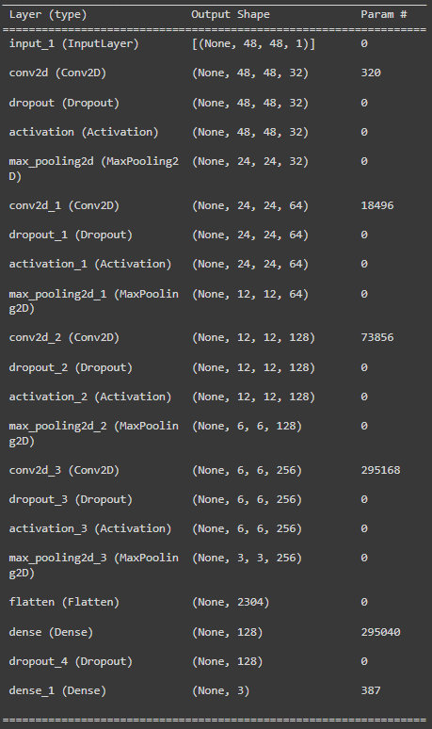

# 10. Face Detection:

## 10.1 Introduction:

OpenCV's Haar Cascade is a machine learning-based approach used for object detection, including face detection. Here's an explanation of how it works:

### Training Haar Cascade Classifiers:

* + The process starts with training a Haar Cascade classifier using a large number of positive and negative images. Positive images contain the object of interest (faces in the case of face detection), while negative images don't have the object.

### Haar-like Features:

* + Haar-like features are rectangular features used in this method. These features are similar to edge or line detectors and capture variations in pixel values in different regions of an image.

### Integral Image:

* + An integral image is calculated for the input image, which helps in fast computation of Haar-like features over different image regions.

### Adaboost Algorithm:

* + The Adaboost algorithm is used to select a small set of important features from the many calculated Haar-like features. These features collectively form the Haar Cascade.

### Sliding Window Approach:

* + During the detection phase, a sliding window technique is applied. A window of a predefined size moves over the image in a stepwise manner, analyzing different regions.

### Feature Evaluation:

* + At each window position, the Haar-like features within the window are evaluated. The sum of pixel intensities in the white region minus the sum in the black region is computed, allowing the system to determine whether the feature is present or not.

### Cascade of Classifiers:

* + The Haar Cascade operates as a series of classifiers arranged in a cascade fashion. At each stage of the cascade, different features are applied. If the window region fails a particular stage, it's discarded, reducing the number of regions to be processed further.

### Thresholding and Detection:

* + A threshold is set for each stage. If the window region's features surpass the threshold, it moves to the next stage. If it fails any stage, it's rejected as not containing the object.

### Final Detection:

* + When a window passes through all stages without being rejected, it's considered a positive detection. The cascade outputs the coordinates and scale of the detected object (face).

### Usage in OpenCV:

* + In OpenCV, Haar Cascade classifiers are implemented through pre-trained XML files. These files contain the parameters of the cascade, enabling the use of these classifiers directly for object detection tasks.

Haar Cascade-based face detection in OpenCV involves a rapid yet effective technique for identifying objects in images or video frames. It's particularly efficient for real-time applications, such as webcam-based face detection, due to its speed and accuracy. However, while robust, it may face limitations in handling variations in pose, lighting, or occlusions.

# 

# 

# 

# 11. Results:

## 11.1 Python Environment Setup:

* The Python environment was set up with the required libraries for face detection, age estimation, gender recognition, and emotion detection (OpenCV, Keras, etc.).

## 11.2 For Sample Images:

### Data Preparation:

* + Gather sample images containing faces for analysis.

### Processing Steps:

* + Load the sample images using OpenCV.
  + Use the Haar Cascade face detector to identify faces in the images.

### Age Estimation, Gender Recognition, and Emotion Detection:

* + For each detected face, apply the age estimation, gender recognition, and emotion detection models.
  + Extract and display the predicted age range, gender, and recognized emotion for each face.

### Visualization:

* + Displayed the original images with annotations, overlaying text or boxes to showcase the predicted age, gender, and emotion for each detected face.

## 

## 

## 

## 

## 

## 

## 11.3 For Real-Time Webcam Input:

### Access Webcam Feed:

* + Used OpenCV to access the webcam feed.

### Real-Time Analysis:

* + Implemented the Haar Cascade face detection on the webcam frames to detect faces in real-time.

### Age Estimation, Gender Recognition, and Emotion Detection:

* + For each detected face in the webcam frames, applied the age estimation, gender recognition, and emotion detection models.
  + Display the predicted age range, gender, and recognized emotion for each detected face on the live video feed.

### Real-Time Visualization:

* + Overlay annotations or text on the live video stream to showcase the predicted age, gender, and emotion for each detected face.

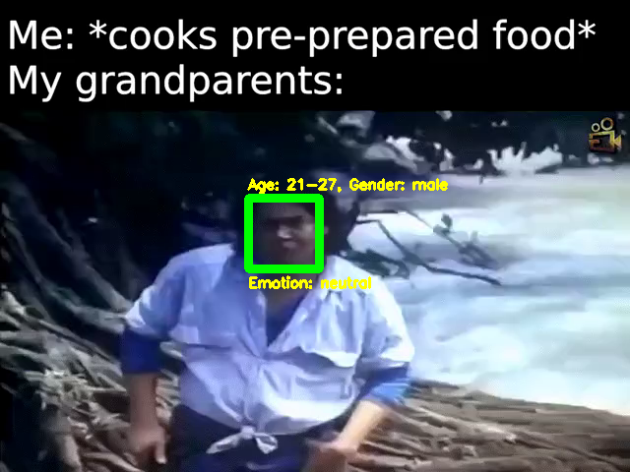

## 11.4 Analysis:

* Analyzed the accuracy of the predictions. Check if the predicted age ranges align with the perceived age, if the recognized gender matches, and if the detected emotions correspond to the facial expressions.
* Noted any discrepancies or challenges, such as cases where the predictions might not align accurately with the ground truth.
* Considered visualizing the results with graphical representations or statistical summaries to showcase the performance of the models in age, gender, and emotion predictions.

Ensured that the system adheres to ethical and privacy considerations, especially in real-time scenarios using webcam input. As obtaining consent and handling sensitive data responsibly is crucial.

# 

# 

# 

# 

# 

# 12. Performance Metrics:

## 12.1 Introduction:

Evaluating the performance of models for age estimation, gender recognition, and emotion detection involves using specific metrics tailored to each task:

### Age Estimation Metrics:

* **Mean Absolute Error (MAE):** This metric measures the average absolute differences between predicted ages and actual ages in the dataset. Lower MAE values indicate better performance.
* **Root Mean Squared Error (RMSE):** Similar to MAE but emphasizes larger errors. RMSE penalizes large errors more heavily and provides insight into the variance of errors.
* **Accuracy within Range:** Considering age groups (e.g., 0-10, 11-20, 21-30, etc.), accuracy within specific age ranges might be calculated to understand how often the predicted age falls within the correct range.

### Gender Recognition Metrics:

* **Accuracy:** The proportion of correctly classified gender predictions from the total predictions made. It measures the overall correctness of gender recognition.
* **Precision, Recall, and F1-Score:** These metrics are particularly useful if the dataset is imbalanced, providing insights into true positives, false positives, and false negatives. F1-score combines precision and recall for a balanced measure.

### Emotion Detection Metrics:

* **Accuracy:** The proportion of correctly identified emotions among all the predictions made. It measures the overall correctness of emotion recognition.
* **Precision, Recall, and F1-Score:** Similar to gender recognition, these metrics help evaluate the model's performance in detecting specific emotions, especially in the case of imbalanced emotion classes.

### Considerations in Evaluation:

* **Confusion Matrices:** These matrices help understand the model's performance across different classes, providing a breakdown of correct and incorrect predictions.
* **ROC Curves (for binary classification):** Particularly in gender recognition, ROC curves can demonstrate the trade-off between true positive and false positive rates at various thresholds.
* **Mean and Standard Deviation:** When using multiple evaluation metrics or conducting evaluations across different models, considering mean values and standard deviations can help gauge overall performance and its variability.
* **Ethical Considerations:** In all evaluations, considering ethical implications, such as biases in gender or age predictions, is crucial. Assessing and addressing any biases in the models' predictions is important for fair and ethical application.

Each metric serves a specific purpose in evaluating the model's performance for the respective tasks of age estimation, gender recognition, and emotion detection. The choice of metrics depends on the specific objectives and characteristics of the dataset used.

## 12.2 **Visualization:**

Visualizations play a crucial role in understanding the data, model performance, and prediction results. Here are examples of visualizations that can be created using Matplotlib, Seaborn, or other libraries:

### Training Process Visualizations:

* **Training Loss and Validation Loss:** Line plot illustrating the change in training and validation loss over epochs during model training, providing insights into model convergence.
* **Model Accuracy over Epochs:** Line plot showcasing the change in accuracy over training epochs, indicating the model's learning progress.

**Age Model:**

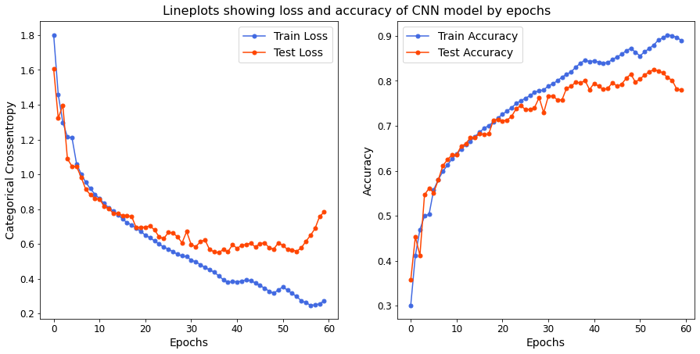

**Gender Model:**

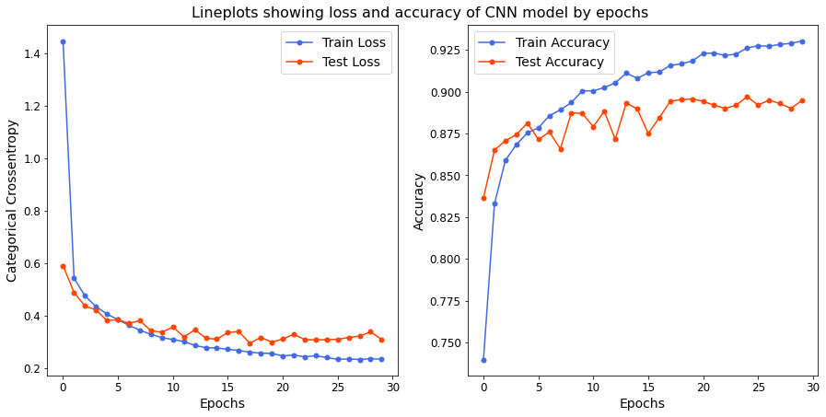

**Emotion Model:**

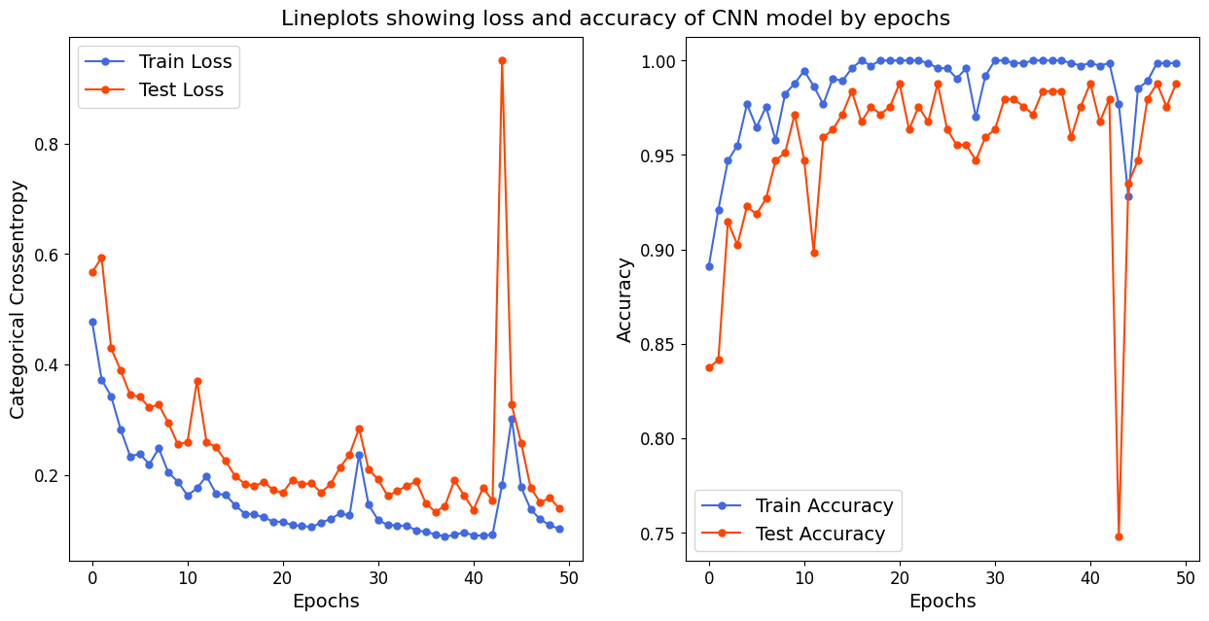

### Prediction Result Visualizations:

* **Confusion Matrices:** Heatmaps visualizing confusion matrices for gender and emotion predictions, indicating correct and incorrect classifications.

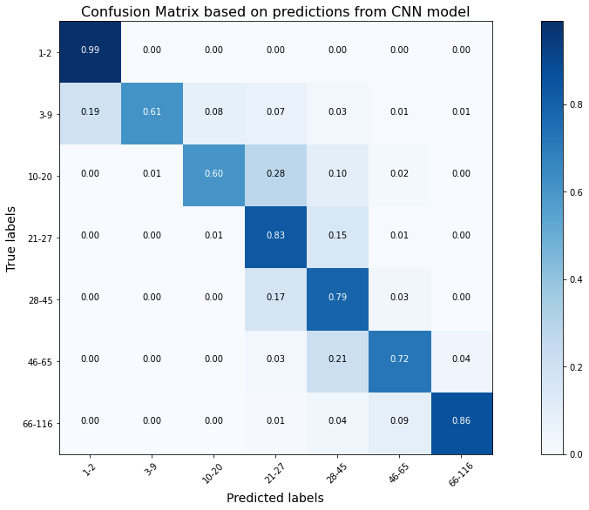

# 13. **Challenges and Solutions:**

In facial identification project development, several challenges can arise, spanning data collection, model training, real-time performance, and ethical considerations.

## 13.1 Data Quality and Diversity:

Insufficient data representation in emotion category which is hindering the model performance.

## 13.2 Model Accuracy and Generalization:

Models are struggling to generalize well to unseen faces, leading to inaccurate age, gender, or emotion predictions.

## 13.3 Real-Time Performance:

Achieving real-time performance in webcam-based applications can be challenging due to the need for rapid inference which makes the video playback choppy.

## 13.4 Interpreting Complex Emotions:

Accurately detecting and categorizing complex emotional states are challenging due to subtle facial expressions.

## 13.5 Adapting to Varied Environments:

Models not performing well in different lighting conditions, poses, or with occlusions.

# 14. Future Enhancements:

## 14.1 Multimodal Fusion:

* **Audio-Visual Fusion:**

Incorporating audio analysis (speech tone, volume, etc.) with facial expressions for more comprehensive emotion detection.

## 14.2 Advanced Models and Architectures:

* **Deep Learning Architectures:**

State-of-the-art architectures (e.g Transformers, EfficientNet) can be used for improved accuracy in age, gender, and emotion recognition.

* **Capsule Networks:**

The use of capsule networks for better feature representation in facial data.

## 14.3 Real-Time Performance Enhancements:

* **Optimized Inference:**

Further optimize models for faster real-time performance, leveraging quantization or model compression techniques.

* **Edge Computing:**

Implementing models on edge devices for on-device processing, reducing latency in real-time applications.

## 

## 14.4 Contextual Analysis:

* **Behavioural Analysis:**

Incorporate behavioural cues or contextual information to refine emotion analysis (e.g., context from conversations or situations).

## 14.5 Personalization and Adaptability:

* **User Profiles:**

Enabling models to learn and adapt to individual users' expressions, enhancing accuracy for specific users.

* **Adaptive Models:**

Developing models that adapt to changing facial characteristics over time for more accurate age estimations.

## 14.6 Explainable AI and Transparency:

* **Interpretability:**

Implementation methods for explaining model decisions, ensuring transparency in predictions, particularly for sensitive applications.

* **Visualizations for Interpretation:**

Providing visual explanations for the model's predictions, displaying important facial features considered during analysis.

## 14.7 Robustness to Diverse Conditions:

* **Cross-Domain Generalization:**

Training models to generalize well across different demographics, cultural backgrounds, and environmental conditions.

* **Adversarial Robustness:**

Enhancing models' robustness against adversarial attacks, ensuring integrity in real-world scenarios.

## 14.8 Continuous Learning and Feedback:

* **Active Learning:**

Implementing mechanisms for models to request human feedback to improve predictions and learn from new data.

* **Continual Learning:**

Designing models that can continually learn from incoming data to adapt and evolve over time.

## 14.9 Ethical Considerations and Fairness:

* **Bias Mitigation Strategies:**

Employing fairness-aware learning techniques to minimize biases across demographic groups.

* **Ethical Impact Assessment:**

Conducting regular assessments to ensure the project aligns with ethical guidelines and societal impact.

## 14.10 User Interaction and Engagement:

* **Interactive UI:**

Developing user-friendly interfaces for users to engage with the system, providing feedback or corrections to enhance the model's performance.

* **Gamification Elements:**

Introducing gamified interactions to make the process more engaging and encourage user participation.

# 15. Conclusion:

The facial identification project yielded several key findings, outcomes, and valuable lessons that contributed to its development and the broader understanding of facial analysis and recognition:

## 15.1 Findings:

### Model Performance:

The project demonstrated successful age estimation, gender recognition, and emotion detection, showcasing the capabilities of machine learning models in analyzing facial attributes.

### Data Importance:

The significance of diverse and well-labeled datasets became evident, impacting the accuracy and generalization capabilities of the models.

### Real-Time Applications:

Implementing real-time facial identification from webcam feeds highlighted the importance of model speed without compromising accuracy.

## 15.2 Outcomes:

### Robust Models:

The project produced models capable of accurate predictions for age, gender, and emotions, offering practical applications in various domains.

### Ethical Considerations:

Heightened awareness of the ethical implications of facial recognition, leading to the integration of fairness, transparency, and privacy considerations into the system's design.

### User Interaction:

The project facilitated the development of user-friendly interfaces, enabling user engagement and feedback for model improvement.

## 15.3 Lessons Learned:

### Data Quality and Diversity:

The importance of diverse and well-balanced datasets was highlighted, emphasizing the impact of data quality on model performance.

### Bias Mitigation:

Addressing biases within the models and ensuring fairness across demographic groups became a crucial aspect of model development.

### Continuous Improvement:

The iterative nature of model development underscored the importance of continual learning, adaptability, and the need for improvements.

### Real-World Application Challenges:

Understanding the challenges in real-world scenarios, such as varying environmental conditions and user diversity, provided insights into the practical implementation of facial identification systems.

The project's findings and outcomes emphasize the significance of ethical considerations, data quality, and continual improvement in facial identification systems.

The lessons learned form a foundation for further advancements in accuracy, fairness, and user engagement, contributing to the responsible and effective deployment of facial recognition technology.

# **References**

* [Age Detection using Facial Images: traditional Machine Learning vs. Deep Learning | by Prerak Agarwal | Towards Data Science](https://towardsdatascience.com/age-detection-using-facial-images-traditional-machine-learning-vs-deep-learning-2437b2feeab2)
* [UTKFace](https://www.kaggle.com/datasets/jangedoo/utkface-new)
* [CKPLUS](https://www.kaggle.com/datasets/shawon10/ckplus)
* [SkillC - YouTube](https://www.youtube.com/@skillcate)
* [NeuralNine - YouTube](https://www.youtube.com/@NeuralNine)
* [Tutorials | TensorFlow Core](https://www.tensorflow.org/tutorials)
* [DeepFace: Closing the Gap to Human-Level Performance in Face Verification - Meta Research](https://research.facebook.com/publications/deepface-closing-the-gap-to-human-level-performance-in-face-verification/)

